**VELAMMAL BODHI CAMPUS**

**GRAND TEST III**

**Max. Marks: 80 SCIENCE BATCH 1 Time: 3 hours**

**General Instructions:**

1. This question paper consists of 39 questions in 5 sections.
2. All questions are compulsory. However, an internal choice is provided in some questions. A student is expected to attempt only one of these questions.
3. **Section A** consists of 20 objective-type questions carrying 1 mark each.
4. **Section B** consists of 6 Very Short questions carrying 02 marks each. Answers to these questions should in the range of 30 to 50 words.
5. **Section C**consists of 7 Short Answer type questions carrying 03 marks each. Answers to these questions should in the range of 50 to 80 words
6. **Section D** consists of 3 Long Answer type questions carrying 05 marks each. Answers to these questions should be in the range of 80 to 120 words.
7. **Section E** consists of 3 source-based/case-based units of assessment of 04 marks each with sub-parts.

### ****SECTION – A****

**Select and write one most appropriate option out of the four options given for each of the questions 1 – 20**

1. If a substance loses oxygen or gains hydrogen during are action it is said to be………………

(a) Oxidised (b) Reduced (c) Tarnished (d) Corroded

2. Reaction between X and Y forms compound Z. X loses electron and Y gains electron. Which of

the following properties is not shown by Z?

(a) Has high melting point (b) Has low melting point

(c) Conducts electricity in molten state (d) Occurs as solid

**3.** A greenish coating develops on copper utensils due to formation of

(a) CuCO3 (b) Cu(OH)2 (c) Cu(OH)2.CuCO3  (d) CuO

**4.** An aqueous solution turns red litmus solution blue. Excess addition of which of the following solution would reverse the change?

(a) Baking Powder (b) Lime (c) NaOH Solution (d) HCl

**5.** What happens when dilute sulphuric acid is poured on silver plate:-

(a) Silver sulphate is formed (b) SO2 gas is evolved

(c) No reaction takes place (d) Hydrogen gas is evolved

**6.** Which of the following statements about graphite and diamond is true?

a) They have the same crystal structure b) They have the same degree of hardness

c) They have the same electrical conductivity d) They can undergo the same chemical reactions

**7.**Reason for strong bond formation by carbon atom is-

(a) Catenation. (b) Small size of carbon atom. (c) Tetravalency. (d) Both (a) and (c).

8. Sometimes we get painful cramps in our leg muscles after running for a long time due to the accumulation of ?

(a) Fat (b) Hydrochloric acid (c) Carbon dioxide (d) Lactic acid

9. Which is the correct sequence of the air passage in man:

(a) Nasal cavity → Pharynx → Larynx → Trachea → Bronchi → Alveoli

(b) Nasal cavity → Larynx → Pharynx → Trachea → Bronchi → Alveoli

(c) Nasal cavity → Pharynx → Trachea → Larynx → Bronchi → Alveoli

(d) Nasal cavity → Trachea → Larynx → Bronchi → Alveoli

10. A person consuming sea food is least likely to develop

(a) Diabetes (b) Goitre (c) Both A and B (d) Heart Diseases

11. What happens in the case of the asexual reproduction of a Spirogyra?

(a) Filaments breaks down (b) Cell division resulting into multiple cells

(c) Division of a cell into two cells (d) Formation of numerous buds

12. Among the following statements given below, choose the one which is true in the case of sexual reproduction of flowering plants.

(i) Fertilisation is a compulsory event (ii) Results in forming of zygote

(iii) Offsprings formed are clones (iv) It requires two types of gametes

(a) (i) and (iv) (b) (i), (ii) and (iii) (c) (i), (ii) and (iv) (d) (ii), (iii) and (iv)

13. Why do scientists think that human-induced global warming will be more harmful to plants and animals than were past, natural climate fluctuations?(a) because temperatures will change faster (b) because the temperature changes will be larger(c) because species now are less adaptable than species in the past(d) because ecosystems are now more complicated than they used to be

14. In humans, if gene B gives brown eyes and gene b gives blue eyes, what will be the colour of the eyes of the person having combination (i) Bb (ii) BB:

(a) (i) Brown (ii) Brown (b) (i) Blue (ii) Blue (c) (i) Blue (ii) Brown (d) (i) Brown (ii) Blue

**15.** What is the maximum resistance which can be made using five resistors each of 1/5 Ω?

(a) 1Ω (b)5 Ω (c)2 Ω (d) 2.5Ω

16. A person cannot see distinctly objects kept beyond 2 m. This defect can be corrected by using a lens of power --------.

(a) + 0.5 D (b)– 0.5 D (c) + 0.2 D (d) – 0.2 D

17.Which of the following statements about the given reaction are correct?

3Fe (s) + 4H2O (g) → Fe3O4 (s) + 4 H2 (g)

(i) Iron metal is getting oxidised (ii) Water is getting reduced

(iii) Water is acting as reducing agent (iv) Water is acting as oxidising agent

(a) (i), (ii) and (iii) (b) (ii) and (iv) (c) (i), (ii) and (iv) (d) (ii) and (iv)

**Following questions consist of two statements – Assertion (A) and Reason (R). Answer these questions selecting the appropriate option given below:**  
(a) Both A and R are true and R is the correct explanation of A.  
(b) Both A and R are true but R is not the correct explanation of A.  
(c) A is true but R is false. (d) A is false but R is true.

**18. Assertion (A):** A geneticist crossed two pea plants and got 50% tall and 50% dwarf in the progeny. **Reason (R) :** One plant was heterozygous tall and the other was dwarf.

**19. Assertion (A):** Alternating Current is used in household supply.

**Reason (R):** AC electric power can be transmitted over long distances without much loss of energy.

20. **Assertion (A) :** The concentration of harmful chemicals is more in human beings. **Reason (R):** Man is at the apex of the food chain

**SECTION – B**

**Q. no. 21 to 26 are very short answer questions**

**21.** H3C—CH2—CH=CH—CH3

(a) Which is the reactive site in the above hydrocarbon?

(b) Write its name.

22. What is the composition of urine? Are glucose and proteins normally present in urine? Why? How is volume of urine regulated?

23. Write the main functions of the following: (a) sensory neuron (b) cranium

24. (a) On what rules inheritance is based? (b) Is each trait influenced by both paternal and maternal DNA?25. Analyse the following observation table showing variation of image-distance (v) with object distance

(u) in case of a convex lens and answer the questions that follow, without doing any calculations:

(a) What is the focal length of the convex lens? Give reason to justify your answer.

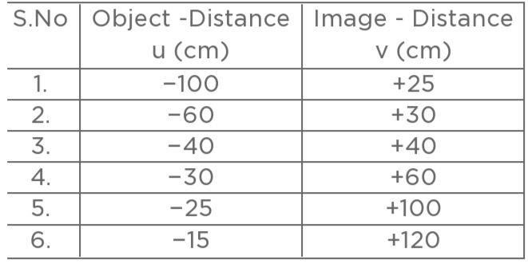(b) Select an appropriate scale and draw a ray diagram for the observation at S.No.2.

**OR**

A student, holding a mirror in his hand, directed the reflecting surface of the mirror towards the sun. He then directed the reflected light on to a sheet of paper held close to the mirror.

(a) What should he do to burn the paper? (b) Which type of mirror does he use?

(c) Will he be able to determine the approximate value of focal length of this mirror from this activity? Give reason and draw ray diagram to justify your answer in this case.

26. What is solenoid? How can you increase the strength of the magnetic field produced by the solenoid?

**SECTION - C**

**Q.no. 27 to 33 are short answer questions.**

**27.**    (a) A doctor applied surgical bandages on the fractured bones of a patient after making it wet. What changes are likely to occur?

(b)In the electrolytic refining of a metal M, what would you take as the anode, the cathode and the electrolyte**?**

**28.**  (a) Write the name and formula of the first member of the carbon compounds having functional group –

COOH.

(b) What happens when ethanoic acid reacts with (i) magnesium and (ii) sodium carbonate?

Write the necessary chemical equation in each case.

29. Explain the manner in which sex is determined in human beings? (**OR**)

Explain how equal genetic contribution of male and female parents is ensured in progeny?

30. (a) What is the height of ozone from the equator?(b) Name the rays against which ozone layer provides protection.(c) Name one effect of depletion of ozone**.**

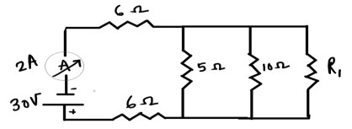**31.** In the given circuit, if the current reading in the ammeter A is 2A, what would be the value of R1?

32. (a) State ohm's law. Express it mathematically.

(b) On what factors does the resistance of a conductor depend?

33. (a) Two wires each carrying a steady current I are shown in two different configurations in Column I. The magnetic field produced due to current in the wires is described in Column II. Match the situations A and B in Column I with all the correct statements in Column II.

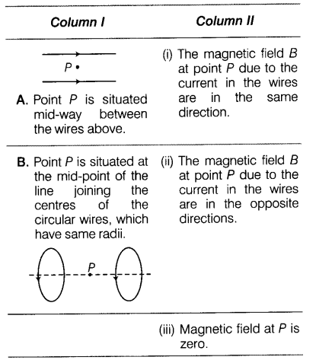

(b) It is established that an electric current through a metallic conductor produces a magnetic field around it. Is there a similar magnetic field produced around a thin beam of moving (i) alpha particles, (ii) neutrons? Justify your answer.

**SECTION - D**

1. **no. 34 to 36 are Long answer questions**

**34. a) The formulae of four organic compounds are given below:**

**A – C2H4 B – CH3COOH C – C2H5OH D – C2H6**

**i. Which one of these compounds A, B, C, or D is a saturated hydrocarbon?**

**ii. Identify the organic acid and give its structural formula.**

**iii. Which of the above compounds when heated at 443K in the presence of conc. H2SO4 forms ethene as the major product? What is the role played by conc. H2SO4 in this reaction? Also, write the chemical equation involved.**

**(iv) Give a chemical equation when B and C react with each other in presence of conc. H2SO4. Name the major product formed and mention one of its important use.**

###### (**OR**)

###### **34. b) Prasad has a saturated alcohol X of chemical formula C4H9OH.**

###### **i. Write the chemical formula of a member Y that comes two places after X in the homologous series and state by how much will its molecular mass differ from that of X.**

###### **ii. How do the chemical properties of X compare with those of Y? Give a reason for your answer.**

###### **iii. Write the chemical formula of the product Z formed by heating Y with acidified potassium dichromate. Write the general formula for compounds in the homologous series that Z belongs to.**

35. (a) In the female reproductive system of human beings, state the functions of:

(i) Ovary (ii) Oviduct.

(b) Mention the changes which the uterus undergoes, when

(i) it has to receive a zygote. (ii) no fertilisation takes place.

(c) State the functions of placenta.

36. (a) Shyam wants to have twice in size of a real image of an object placed at 25 cm from a convex lens.

(1) Specify the distance of image from the lens. (2) Find the focal length of the lens.

(3)) Find the power of convex lens.​

(b) Which mirror is used in headlights of cars? At what position is bulb placed in it and why?

**SECTION - E**

**Q.no. 37 to 39 are case - based/data -based questions with 2 to 3 short sub - parts. Internal choice is provided in one of these sub-parts.**

37. The excretory system of human beings includes a pair of kidneys, a pair of ureters, a urinary bladder and a urethra. Kidneys are located in the abdomen, one on either side of the backbone. Urine produced in the kidneys passes through the ureters into the urinary bladder where it is stored until it is released through the urethra.

i) What is the purpose of making urine? ii) What is Bowman’s capsule? iii) What is dialysis?

iv) What is the function of urinary bladder? (or) iv) What are the different parts of nephrons?38. Sodium hydroxide When electricity is passed through an aqueous solution of sodium chloride (called

brine), it decomposes to form sodium hydroxide. The process is called the chlor-alkali process because of the products formed– chlor for chlorine and alkali for sodium hydroxide.

i) Write the chemical equation involved in this process?

ii) What are the substance that are formed at anode and cathode on chlor- alkali process?

iii) What are the uses of chlorine?

iv) Where does the sodium hydroxide solution is formed? (or)

iv) What are the uses of Sodium hydroxide?

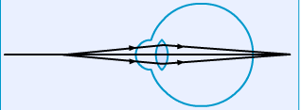39. Given below is a diagram showing a defect of human eye. Hypermetropia is also referred to as hyperopia or long-sightedness, or far-sightedness. Hypermetropia is the condition of the eyes where the image of a nearby object is formed behind the retina. Here, the light is focused behind the retina instead of focusing on the retina.

(a) **List two structural defects that are responsible for hypermetropia condition.**

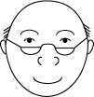**(b) Name the type of lens which is used to correctv 1) Myopia 2) Hypermetropia**

c) The picture given here shows a person wearing 'half-moon' spectacles. What sort of eye defect do you think he has? Why are these particular spectacles useful to him?

**(OR)**

**What is meant by the term power of accommodation?**

*** ALL THE BEST ***